Vocabulario - El Dia de los Muertos

dos de noviembre = November 2nd
El Dia de los Muertos = Day of the Dead
la muerte = death
el pan de muerto = traditional sweet bread (“bread of the dead”)
el cempasúchil = yellow and orange flowers (marigolds)
las calaveras = skulls
el esqueleto = skeleton
las catrinas = skeletons dressed in fancy clothing, often female
la ofrenda = offering; usually an altar to honor ancestors
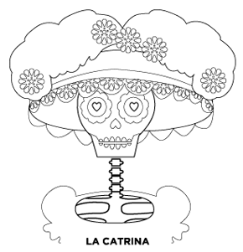
papel picado = decorative tissue paper banners (“cut-up paper”)

