Nombre: _____________________ Clase: ___________________________
Label the picture with the correct vocabulary word.
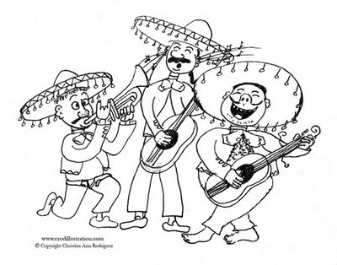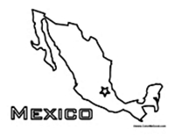
________________________________ ___________________________________

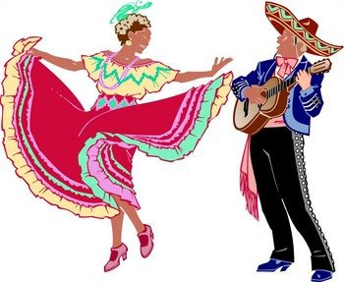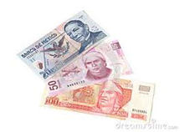
_________________________________ ____________________________________

Circle the correct answer.
A popular dish cooked in Mexico is el serape / los tamales.
The colors red, white, and green are found on la bandera de Mexico / el sombrero
The capital of Mexico is called Mexico D.F. / Cozumel.
The money used in Mexico is euros / pesos.
A typical dessert in Mexico is tacos / flan.

