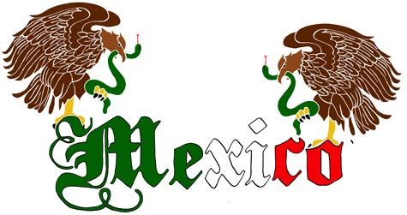

El sombrero = large wide-brimmed hat
Las maracas = maracas
La piñata = piñata
Mariachi = music from Mexico
La bandera de México = Mexican flag
Pesos = money used in Mexico
México D.F. = México City
Los tamales = tamales, popular food baked in a corn husk
Flan = typical dessert
El serape = colorful woven shawl/blanket
La bailarina tradicional = traditional dancer
Los elotes = corn

