PASAPORTE
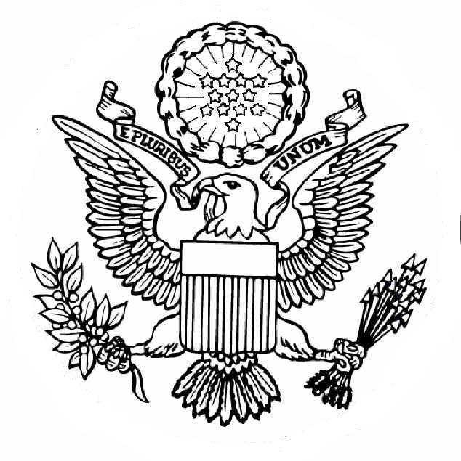

Clase de español: AS Beginner
Información personal

______________________
Nombre (Name)

__________________________
Apellido (Last name)

__________________________________________
Fecha de nacimiento (Date of birth)

__________________________________________
País de nacimiento (Country of birth)

_________________________________________________
Nacionalidad (Nationality)

_________________________________________________
Correo (Address)
_________________________________________________
Color de ojos (Eye color)

_________________________________________________
Color de pelo (Hair color)

_________________________________________________
Estatura (Height)

_________________________________________________
Fecha de expedición (Date of issue)
PÁGINA DE VISITAR

Nombre de país: _________________________
Facts about this country:
1.
2.
3.
4.
Something new I learned about their culture:

New words I learned while studying this country:
1.
2.
3.
4.

